Cricket fixer is a person who corrupt player for fixing a cricket match. Which is called fixed cricket match. There were so many cricket fixer in [Al Jazeera](https://www.aljazeera.com/)'s report. There are various kinds of fixing like spot fixing, match fixing, session fixing. You will get proper idea of everything in this respect and which international crickerts are involved in fixing in which matches.

[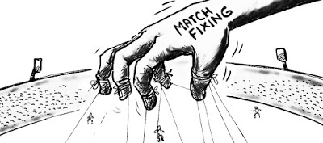](https://3.bp.blogspot.com/-umFJMm0nFRQ/W9Fp8ppvsRI/AAAAAAAAAag/BHSnThlCV5Q_2EZpS33f6Lbv79b13AS8QCLcBGAs/s1600/Cricket%2Bfixer%2Band%2Bfixed%2Bcricket%2Bmatch.jpg)

**What is spot-fixing in cricket?**

**Spot-fixing term means, dishonest action taking by cricketers for a particular outcome which will influence the game result**. Nowadays spot-fixing is the main headache of [ICC](https://www.icc-cricket.com/). Fixers fix the match for a purpose. They do business in the betting market by knowing the exact outcome of the match.

[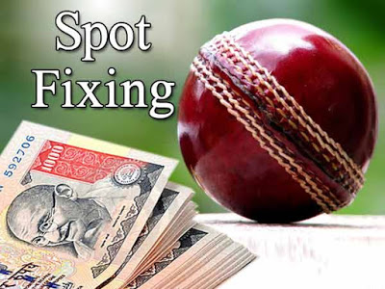](https://2.bp.blogspot.com/-UptEDaoVU5Q/W9FqOLkOMHI/AAAAAAAAAao/VY4ozVfpTfE7B5V6HtAgyp6puAT25pt8ACLcBGAs/s1600/whta%2Bis%2Bspot%2Bfixing.jpg)

**Session fixing:**

Session fixing is one kind of [spot-fixing](https://en.wikipedia.org/wiki/Spot-fixing). In session fixing, f**ixers target a particular session of 10 or 20 overs**. Session fixing is now the most popular, over the match-fixing or spot-fixing. In targeted over fixers influence the batsman to under perform. The deal between cricketers and fixers occurs before the match.

I will explain briefly about the session fixing point by point you just have to hang on and keep reading. You will also know about the recent session fixing and fixers.

**How the session fixing works:**

Who fixes the match or spot or a particular session is called a **cricket fixer**. Work policy of a fixer is kind of complicated. For a session fixing a fixer have to deal with cricketers and money. Fixing can be done in any format of the cricket.

Suppose, there is an upcoming match of the team 'x' and team 'y'. First of all, fixer will target some players from both of the team. Then they will approach for these players. Every player is not corrupted so their approach won't be successful for all the players. As we are assuming with two teams 'x' and 'y'. We assume that two players of the team 'x' got influenced by the fixers. Fixers offer the players a huge amount of money for doing this fixing. Fixers most of the time target the batsman. Then fixer will tell the two players of the team 'x' two under perform in some particular over. Under perform means not scoring as many runs in some overs. They will play defending shot and also they will keep the run rate low.

Sometimes a player decides when the session fixing will start. He will give a **signal** to the fixer. Like **taking off his pad or helmet. Or changing the gloves**. When the player gives the signal fixer understand that session is started. Then the fixer tells his customers that the betting market is open. And raise the bait as high as customers can. According to [Al Jazeera](https://www.aljazeera.com/)'s report, when fixers fix the session batsman who is corrupted keep the run rate low from the regular prediction of [betting bookies.](https://en.wikipedia.org/wiki/Bookmaker) As customers of the fixers know the outcome of the particular over. From those particular over they make huge money. After the session ends fixer close the betting market and the profit is on their hand.

[](https://2.bp.blogspot.com/-7xi5pvu68dw/W9FtH6tZGpI/AAAAAAAAAcA/nceWcLmb4zgXKS_4BVoP_2k2fj2x6v5MACLcBGAs/s1600/match%2Bfixing.png)

**15 fixed cricket match according to Al Jazeera:**

* Australia vs England (ODI- 21 January 2011)
* Australia vs Zimbabwe (ODI world cup- 21 February 2011)
* England vs the Netherlands ( ODI world cup- 22 February 2011)
* Australia vs Kenya (ODI world cup- 13 March 2011)
* England vs South Africa (ODI world cup- 6 March 2011)
* England vs Bangladesh (ODI world cup- 11 March 2011)
* England vs India (Test- 21 to 25 July 2011)
* Australia vs South Africa (Test- 9 to 11 November 2011)
* Australia vs New Zealand (Test- 9 to 12 December 2011)
* England vs Pakistan (Test- 17 to 19 January 2012)
* England vs Pakistan (Test- 25 to 28 January 2012)
* England vs Pakistan (Test- 3 to 6 February 2012)
* Srilanka vs Zimbabwe (T20 world cup- 18 September 2012)
* England vs Afghanistan (T20 world cup- 21 September 2012)
* South Africa vs Pakistan (T20 world cup- 28 September 2012)

**How Al Jazeera's reporter mixed with the cricket fixer:**

Through an underworld connection, Al Jazeera's one reporter met with a man named Munawar. He is a professional fixer working under a gangster company naming with **'**[**D Company**](https://en.wikipedia.org/wiki/D-Company)**'**. Reporter introduced himself as a co-operator of some wealthy investors. The reporter said to Munwar that these investors are interested in fixing and betting market. They want to make quick money with the betting market. The reporter met with Manwar on some occasion. There was also a hidden camera. Those conversations were recorded.

**D Company:**

[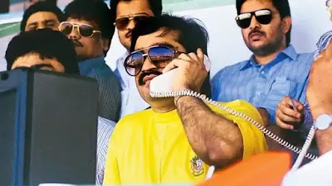](https://3.bp.blogspot.com/-u3hEnoa1TKQ/W9FsU3xK_RI/AAAAAAAAAbs/gjEs8ByPr2MlRlR3L8m15Nk6fTXk1a-SwCLcBGAs/s1600/Dawood%2BIbhrahim.jpg)

As other gangsters opinion, [**D Company**](https://en.wikipedia.org/wiki/D-Company) is named after the wanted [Dawood Ibrahim](https://en.wikipedia.org/wiki/Dawood_Ibrahim). He is wanted in many countries for his illegal works. He also has a betting business of his own. He earns his most of the money from this business. Manowar is his main man in the betting market. Munawar operates all the work of betting for Dawood Ibrahim or his so-called '[D Company](https://en.wikipedia.org/wiki/D-Company)'.

**Cricket fixer who are deeply involved in fixed cricket match:**

Most wanted cricket fixer in ICC's list is **Munawar**. He is working for D Company in the betting market approximately 7 to 8 years. He is the smartest fixer as Al Jazeera's point of view. His 25 fixing from 26 are correct. His work is so much pure.

[](https://4.bp.blogspot.com/-jnf2kuahyY0/W9FrC9xK50I/AAAAAAAAAbE/ETFkWRxYuw8qxkuV5fwB9fD-VtJY01FQQCLcBGAs/s1600/Munawar.jpg)

There are also two Cricket fixer's in Al Jazeera's report. Two names are **Robin Morrison** and [**Hasan Raza**](https://en.wikipedia.org/wiki/Hasan_Raza). Both of them are former cricketers. Now retired and corrupting the gentleman's game.

[](https://2.bp.blogspot.com/-0MCTNJtCyhU/W9FrL1s2XxI/AAAAAAAAAbI/pD8Hu11N3B0GLbfkrIsAo7KpUJmU6FZEwCLcBGAs/s1600/Robin%2BMorrison%2Band%2BHasan%2BRaza.jpg)

**Top cricketers with cricket fixers:**

[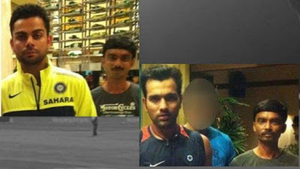](https://1.bp.blogspot.com/-CgOmCpz8lkM/W9FrXBLPHsI/AAAAAAAAAbQ/ysRpait6dSIt67U8H-JHWFn-W9_pfgrtwCLcBGAs/s1600/munawar%2Bwith%2Bvirat%2Band%2Brohit.jpg)

Some top-level cricketers are seen with fixers. Most of them were with **Munawar**. He was seen with [Virat Kohli](https://en.wikipedia.org/wiki/Virat_Kohli), [Rohit Sharma](https://en.wikipedia.org/wiki/Rohit_Sharma), [Chris Gayle](https://en.wikipedia.org/wiki/Chris_Gayle), [Darren Sammy](https://en.wikipedia.org/wiki/Darren_Sammy), [Tim Bresnan](https://en.wikipedia.org/wiki/Tim_Bresnan). But **none of them was convicted or proven for fixing.** But according to Al Jazeera, there are most of the corrupted cricketers from England, Australia and Pakistan. **From the list of 15 matches, England was in 8 matches**. Al Jazeera not revealed any of the names of the cricketer. They will reveal the names to proper authorities.

[](https://1.bp.blogspot.com/-K6Ku6WQrONY/W9FrtsyMwCI/AAAAAAAAAbc/OCglod3gsBYCjtcRDcXcI9kwB7cbxcopQCLcBGAs/s1600/munawar%2Bwith%2Btim%2Bbresnan.jpg)

**Previous steps of ICC about  fixed cricket match:**

ICC always said that in the previous year, they will show zero tolerance for a cricket match, spot or session fixing. South African captain in 2000, New Zealand cricketer [Lou Vincent](https://en.wikipedia.org/wiki/Lou_Vincent), Pakistani three cricketers, Bangladeshi cricketer [Mohammad Ashraful](https://en.wikipedia.org/wiki/Mohammad_Ashraful) were ICC's some example for fixing in cricket.

[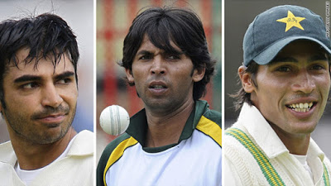](https://3.bp.blogspot.com/-xJVN0Ie6XIY/W9FsAatqczI/AAAAAAAAAbk/lN1SYd9Y55k7ivrDcxalUrHwt9ddJQ9awCLcBGAs/s1600/banned%2BPakistani%2Bthree%2Bcricketers.jpg)

There is a matter that, [ICC](https://www.icc-cricket.com/) knew about the Munawar since 2010 according to [Al Jazeera](https://www.aljazeera.com/)'s report. But they didn't take any steps against Munawar. For that Munawar continuously corrupted the game.

**Future steps of ICC:**

[Al Jazeera](https://www.aljazeera.com/) submitted their report to ICC. ICC also tweeted about **wanted Munawar.** They also questioned some of the cricketers. I assume that soon ICC will come up with some unexpected news about fixing. Because of this time, they are serious and will show zero tolerance for fixing.

[](https://3.bp.blogspot.com/-Nu2kIyxuvZQ/W9FskrAMT6I/AAAAAAAAAbw/yIiSZVGGPZIFWEpMSwVHbxc6GiQo3VxeQCLcBGAs/s1600/no%2Bto%2Bmatchfixing.png)

**Conclusion:**

A cricket match, spot or session fixing is totally illegal. Those who are with this corrupted part of cricket they should be punished. Otherwise, this game won't be a gentleman's game anymore. Say no to fixing.

For more update, hang on with our blog.

**Source:**

1)  [Cricket Match Fixers](https://www.youtube.com/watch?v=uYlk4izYVmw)

2)  [Cricket Match Fixers: The Munawar Files](https://www.youtube.com/watch?v=z13N6pGfRMs)